October, 2018

Gloria Dimon, UniServ

Representative

Local Spotlight On: Clinton and Madison

In this issue:

* Need Help Building a More Effective Local?

* School Safety and Bullying

* Evaluation

* In the Spotlight

School Safety and Bullying

The week of October 21st is national school safety week and one way to help improve the safety of students in your district is to address school bullying. Most educators recognize this as a problem but might not know where to start. The NEA has created a multitude of resources to help identify, intervene and advocate for bullied students. Please follow this link for ideas on how you can help: http://www.nea.org/home/63898.htm

Need Help Building a More Effective Local?

JFK was right, your Union matters! If you’re reading this, you probably are well aware of this already. But maybe you wish your union was stronger, was more effective, or could just do more? That’s where CEA comes in with our latest round of CEA Local Grants to Build More Effective Locals. CEA Local Grants purpose are to provide local associations with additional funding for services and programs that they might not be able to provide on their own. Examples include things like payment for trainings, workshops, technological enhancements, recruitment, etc. CEA firmly believes that like public education students, everyone deserves a quality local, regardless of their funding ability. Grant applications are due December 1st, but now is the time to submit. Applications can be found at the following link: http://www.cea.org/members/treasurers/getFile.cfm?type=pdf&loc=/members/treasurers/index.cfm&getFile=Grant-Letters-Application

Don’t let your great ideas for your local go to waste, apply today!

Happy Halloween!!

Upcoming Events:

Teachers and the Law
November 5 4-6 pm
Haddam Killingworth Middle School Library

Uniserv Brewery Tour
Nov. 9 – see page 3!

Know Your Rights, with Chris Teifke, CEA UniServ Rep

Do you have questions about your individual situation with evaluation? Your UniServ Rep would be happy to help you.

Please call 860-691-5031.

UniServ Rep Chris Teifke taking another member call.

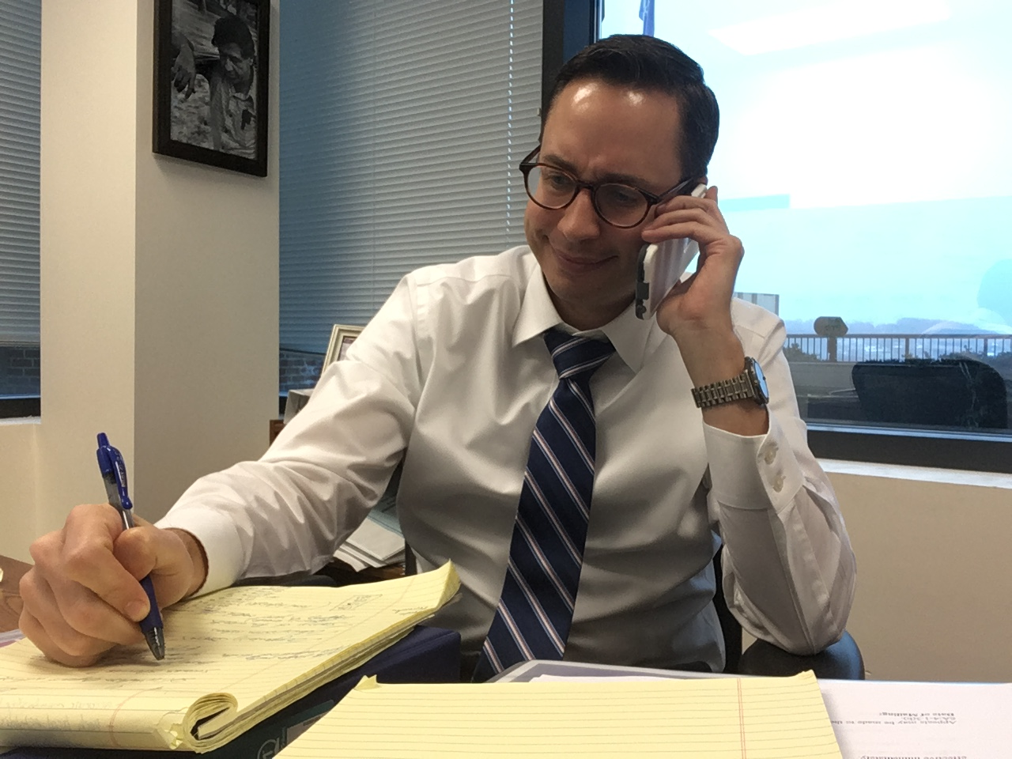
Therefore, when your evaluator is coming in for a formal observation, be sure to include a highly interactive lesson that gives students an opportunity to demonstrate a reasonably high level of ownership of the lesson. Activities such as debates, collaborative groups with differentiated roles, Socratic circles, and inquiry labs are all excellent for evaluators to see, provided they are carefully structured with clear routines and transitions in place. Also, be sure to involve several different forms of assessment throughout your lessons. Several different assessments spread out over the course of your lesson will ensure your evaluator sees at least one during the observation even if he or she is there for only part of the class period. Have a toolbox of very quick formative assessments handy that you can use at almost any point in the lesson to determine whether or not students are able to demonstrate an understanding of an essential concept. This is particularly impressive if you can show how you used formative assessments to adjust instruction or form collaborative groups.

What should you do if an evaluator leaves before you have finished your lesson? If your evaluator leaves your room without observing an important aspect of the lesson, provide evidence that you did touch on the domain or indicator that they missed. Most commonly, evaluators leave before seeing assessment. If this is the case, bring the assessments you used in the lesson to your post-conference to share with your evaluator.
My evaluator just assigned me my SLO. Can they do that?

No. Mutual agreement is essential in major decisions between evaluators and teachers, including decisions on all student learning goals and indicators of growth and development (IAGDs). Mutual agreement is a requirement at nearly every step of the TEVAL process, and without it, the entire process may be jeopardized.

What to do if you do not agree with your evaluator on goals and/or indicators:

If mutual agreement is not reached between an evaluator and teacher on SLOs or any other issue requiring mutual agreement, the issue must go through an impartial dispute resolution process. If this does not happen, it constitutes a misstep in the TEVAL process, and the matter can be grieved.
You should not be forced to accept an SLO or an indicator that you believe is not fair, valid, reliable, or useful for your student population or content area. Be sure to ask a CEA representative—your building representative, local president, CEA specialist, or trusted colleague—if you are unsure how to proceed. Other teachers will have advice and experience and might suggest alternatives you had not considered.

I’m a great teacher but I can’t seem to get an exemplary rating. Any tips for how to accomplish this?

The main difference between the two highest ratings in an observation is the degree of autonomy students demonstrate over their own learning. →
Being evaluated can be a nerve wracking experience for even the most experienced teacher. Let’s take a look at some commonly asked questions:

I’m non-tenured in my first few years teaching. What are some tips to successfully getting through my first evaluations?

1.) Ask your evaluator for guidance: Use your evaluator as a resource and ask for strategies, feedback, and resources. Be receptive to your evaluator’s feedback, which is necessary to help you improve.

2.) Deadlines matter: If your evaluator misses a deadline for an observation or you do not receive feedback in a timely fashion, send a friendly email to remind your evaluator. As an untenured teacher, you want feedback early in the year so that you have ample time to demonstrate improvement.

3.) Align SLOs with your TEAM goals: While you should not feel pressured to do so, aligning your SLOs and TEAM goals could save you valuable time and reduce your workload and stress.

4.) Rely on your TEAM mentor: Your TEAM mentor is an invaluable support in your first two to three years in the teaching profession. Not only will your mentor guide your through TEAM, he or she can also help you in many other ways. Your mentor can advocate on your behalf with school administration for needed resources or release time to work on TEAM modules or watch peers teach. If you and your mentor are not a good match, try to resolve your differences, but also do not hesitate to respectfully request to make a change.

Page 2 of 3

This Month’s Topic: Evaluation

Page 3 of 3

U
B
T

STOP
1

Don’t miss it!

The EAC sponsored a candidate forum at a general membership
meeting on October 15th. Three of the four invited candidate attended and answered challenging questions on teacher pensions, teacher safety,
and collective bargaining. The MEA will be sponsoring a similar forum
for two candidates on October 24th. Great job to both locals for keeping
members informed in this important election.

Uniserv Brewery Tour

The CEA Norwich Regional Office is proud to announce the first annual Uniserv Brewery Tour! Multiple times throughout the year the intrepid Uniserv reps of the Norwich Office will pick a location to gather for a little training, some ripping food, and plenty of revelry. Come ready to learn, ready to eat, and ready to let off a little steam socializing with your fellow educators, because you deserve it! Attendance and food are free, but please register by emailing kathys@cea.org. And without further ado, the first stop on the tour is…The Jealous Monk in Mystic, CT! Don’t miss out on the premier event.

U.B.T. Stop 1

Location: Jealous Monk, Mystic CT

Date: Friday, November 9, 2018

Time: 4:30
Training Topic: “What Would You Do?”
Your UniServ Reps have seen it all. Arrests, television appearances, severed limbs, you name it, it’s happened. But what if you were the building rep? How would you handle the oddball situations that come up in the line of duty? Come to this interactive workshop detailing the tough cases that are bound to happen eventually.

Followed by a rollicking good time!

