

**September, 2018**

Gloria Dimon, CEA UniServ Rep

Welcome Guilford, Madison, Clinton, Westbrook, Old Saybrook, Region 4, H-K, and egion 13 teachers!

***In this issue:***

***\* It’s Bargaining Season!***

***\* Certification***

***\* In the Spotlight***



It’s Bargaining Season!

Yes Members, it is that time of year when many of you and your colleagues, along with your CEA UniServ Representative, are putting together contract proposals that will govern your future salary, benefits and working conditions! CEA Representatives in the Norwich office alone will be negotiating 23 different local contracts on the eastern side of the state. Your bargaining team coworkers will be spending many nights, after teaching all day, crafting contract language, studying healthcare trends and crunching numbers to win the best possible salary increases for you and your colleagues.

In Connecticut we are fortunate to have one of the highest concentrations of association membership nationwide. This strength in solidarity is reflected in the fact that our average teacher salaries are ranked fifth in the country, and by the large number of negotiated benefits contained in our collective bargaining agreements. Our high membership density also means that unlike most associations, CEA members receive absolutely free legal representation in a host of matters including DCF Investigations, Worker’s Compensation, teacher termination, and unemployment, in addition to receiving other professional development, support and protections.

But strong contracts don’t happen just by sitting back and letting the team do all the work, the best contracts happen when all the teachers participate. So if your Local Association is negotiating a new contract this season, please show support for your Negotiating Committee members. Take the time to answer negotiation surveys; attend informational meetings; make a show of solidarity by wearing a pin (we can supply them) or wearing a certain color clothing on a particular day; prepare a small dish or snack for your team during one of their long negotiating meetings or all-night mediations; and thank them for devoting their precious time and energy toward improving your, and the lives of all of our members. Our strength lies in our solidarity.



***Upcoming Events:***

***CEA New Teacher Conference***

***October 20, 2018***

***New London County Forum***

***October 24, 2018***

LABOR DAY

#### Do you have questions about your individual situation with certification? Your UniServ Rep would be happy to help you.

#### Please call her at

#### 860-691-5031 or email her at gloriad@cea.org.

Bilingual Education (PK-12), Comprehensive

Special Education (K-12), Mathematics (7-12), Occupational Subject, Vocational Technical High School, School Library and Media Specialist, Science (7-12), Speech and Language Pathologist, Technology Education (PK-12), TESOL (PK-12), and World Languages (7-12).

* A teacher must have 12 credits or more in a shortage area to teach in it.
* The district must be unable to find a certified person to do so. The district must show to the SDE that it advertised for the position for which it is requesting the DSAP.
* DSAP applications must be signed by both the teacher and the district.

**What about retirement credit if I teach under a DSAP?**

Retirement credit is given under a DSAP in the same manner as any other teaching certificate.

However, the district and the teacher could apply for a special waiver called a temporary authorization for a minor assignment. To qualify, (1) The certificate holder has at least 12 semester hours of credit in the subject to be taught; (2) The certificate holder possesses a certificate endorsed for an academic subject or a special subject, or special education; (3) The minor assignment shall supplement a primary assignment; and (4) The number of instructional periods for the minor assignment shall not be greater than two periods per day.

**What about DSAP positions, I’ve heard those are different.**

Acquiring a Durational Shortage Area Permit (DSAP) for a person to teach outside of certification has several legal requirements for both the teacher and the employing Board of Education.

* The subject area in which DSAP is being taught must be identified as a shortage area by the State Department of Education.
* The following certification endorsements are identified as shortage areas for the 2018-19 school year:

**Know Your Rights**, with Gloria Dimon and Chris Teifke, CEA UniServ Reps

Page 2 of 3

This Month’s Topic: Certification



**C**ertification has only become more complicated over the years. It can be hard to keep up with the breadth and scope of the requirements. Let’s take a look at some commonly asked questions:

**According to my principal, the Connecticut Department of Education allows teachers at the secondary level to teach one class out of their area of certification, is this true?**

Absolutely Not! Teachers may only teach in the subject area for which they are certified.

**The district really needs somebody to teach a chemistry course at the high school. I’m only certified in biology. I’d like to do it as I see it as job security for myself. What’s the worst that can happen?**

It’s definitely playing with fire. A teacher who teaches any part of an assignment outside of his or her area of certification jeopardizes accumulating retirement credit for whatever portion is taught outside of certification. Retirement credit is only awarded to individuals properly employed in areas for which they are certified (they would thus be considered part-time employees).

The first Labor Day holiday was celebrated on Tuesday, September 5, 1882, in New York City. Following the deaths of 13 workers during the Pullman Strike in June of 1894, President Grover Cleveland put reconciliation with the labor movement as a top political priority and Labor Day became a federal holiday and grew to become a federal holiday in 1894.

**Local Spotlight On: The Norwich Regional Office**

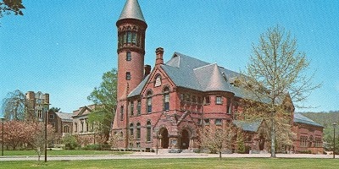

Norwich Free Academy, site of the 2018 CEA Regional Summer Bash!



********************



Page 3 of 3

#### 

# In August CEA Norwich Regional Office hosted a very well received Summer Bash! Dozens of participants from several locals across the region gathered to learn about a variety of topics from personality typing, to social media usage to uniserv’s toughest cases. The merriment was wrapped up at the local watering hole, These Guys Brewery. We’re looking forward to providing another fun Summer Bash next year!

**CEA Member Benefit of the Month:**

**The CEA Teacher Tailgate!**

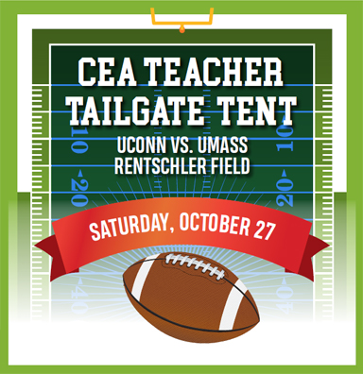

## Join us for some pregame festivities, food, and fun!

The tailgate tent is **free for teachers**, but you must register to reserve your spot. Registration is on www.cea.org

Don't forget to buy your discounted game tickets by contacting **Robert Luden** at 860-486-8189 or [robert.luden@uconn.edu](mailto:robert.luden@uconn.edu). Mention that you are a CEA member. $15 second-level end zone, $30 lower sidelines.