Spring, 2019

Gloria Dimon, CEA UniServ Representative

SPOTLIGHT ON – Madison, Clinton, Region 4, and Region 13 for completing all of the new CEA membership forms! Great job!



Connecticut Legislative Session is in Action!

The Connecticut Legislature is in full swing and taking up many issues that potentially have a huge impact on you and your teaching. CEA is working on these every day but the most effective impact comes from legislators hearing directly from their constituents. That’s you! Here are some of the most hot button issues being discussed:

**Retirement:** We want to protect the funding and defined benefit structure for current retirees as well as active and future teachers, not to mention repealing the 1% additional contribution!

**Safe Learning Environment:** Protect teachers and students from physical harm and trauma resulting from violent student behavior; provide non-punitive services to help aggressive students. The bill requires local boards to be notified of incidents and responses, and for schools to have plans for helping students who have been removed from class for violent behavior.

**FMLA Changes:** The legislature is attempting a bill that would have teachers eligible for $1,000 a week of paid leave while they are on FMLA leave, but only if they pay an additional required .5% of their salary. This would be very detrimental to many of you who have a much better benefit in your contracts already.

If any of these issues mean anything to you I highly encourage you to call you legislators NOW as they are voting on them as we speak. Make your voice heard!

***In this issue:***

***\* Connecticut Legislative Session is in Action!***

***\* Know Your Rights:***

***Non-Renewals***

***\* UBT Stop #4***

***Upcoming Events:***

***Middlesex County Forum – April 2***

***Uniserv Brewery Tour***

***April 25 – see page 3!***

**Know Your Rights**, with Gloria Dimon and Chris Teifke, CEA UniServ Representatives



**What rights do I have if the non-renewal is for cause?**

A teacher has very limited rights under the Fair Dismissal law if the non-renewal is for cause. If a teacher files a written request, the board must supplement the non-renewal notice with a written statement of its reasons for non-renewal within seven days of receiving the request. Additionally, a teacher has the right to a hearing before the Board of Education in which the Board of Education shall rescind a non-renewal decision only if such decision is deemed arbitrary and capricious. Simply speaking, the Board of Education merely needs to find that “a reason” exists for the non-renewal. As such, the Board of Education does not review the merits of the non-renewal.

**If I am concerned about being non-renewed for cause, what should I do?**

You should speak to your local union representative as soon as you become concerned about negative observations or meetings in which performance issues are discussed. Your union will help you navigate the evaluation process.

This Month’s Topic: Non-Renewals

#### Do you have questions about your individual situation with a non-renewal? Your UniServ Rep would be happy to help you.

#### Please call her at

#### 860-691-5031.



**When would I have to be notified if I am being non-renewed?**

Typically, the administration will inform non-tenured teachers of a planned non-renewal informally. The statutory deadline for a vote by the Board of Education for a non-renewal is May 1st.

**Why would there be a Reduction in Force in my district?**

The two most common reasons are that the student enrollment has decreased in the district or that the Board of Education simply needs to reduce its budget.

**What rights do I have if I am I teacher who is recommended to be laid off due to a RIF?**

You have no statutory right to contest the lay-off in a hearing before the Board of Education. However, you may have rights under your collective bargaining agreement (contract between the Board of Education and your teachers’ union.) Please check with your local union representative and/or your CEA UniServ Representative to understand any rights afforded in the contract.

**T**his is the time of year many new teachers face the possibility of a non-renewal. What does this mean and what are your rights? Keep reading to find out.

**I’m a non-tenured teacher and have heard talk that non-tenured teachers are facing possible non-renewals and RIF’s. What does this mean?**

a. Non-renewal is the term used when a non-tenured teacher is recommended for dismissal by the Superintendent, and the Board of Education votes to follow this recommendation.

b. The term RIF is an acronym for “reduction in force.”

**For what reasons may a non-tenured teacher be non-renewed?**

A non-tenured teacher may be non-renewed for cause or because the district is reducing the number of teachers employed.

Page 2 of 3

#### Uniserv Brewery Tour Stop #4! 2 for 1???

Page 3 of 3

Everyone please welcome th newest addition to CEA K9 Division, Emmutt Teifke!



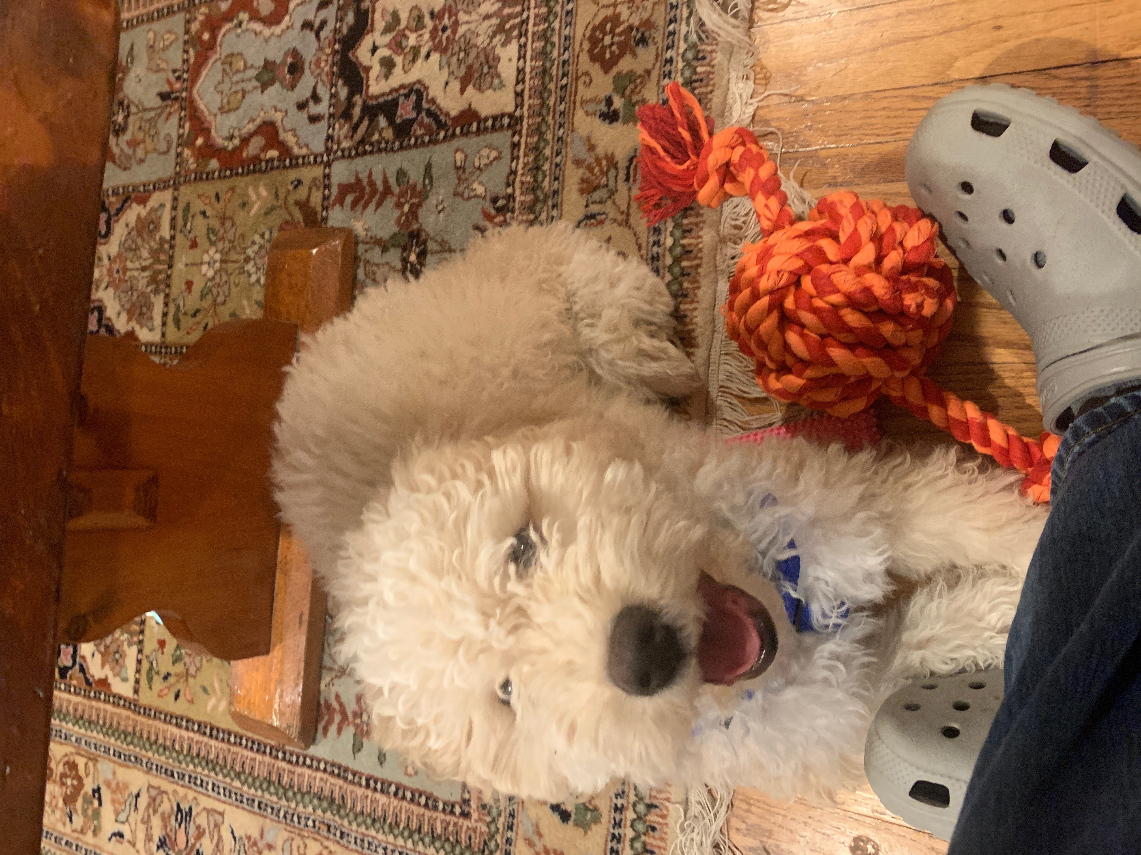

Emmutt is a 12 week old Spanish Water Dog whose interests include Social Justice, Public Education and chewing on sneakers. He is very excited to join the team and help all teachers with a smile after a rough day. Welcome Emmutt!



# The CEA Norwich Regional Office is proud to announce the first annual Uniserv Brewery Tour! Multiple times throughout the year the intrepid Uniserv reps of the Norwich Office will pick a location to gather for a little training, some ripping food, and plenty of revelry. Come ready to learn, ready to eat, and ready to let off a little steam socializing with your fellow educators, because you deserve it! Attendance and food are free, but please register by emailing [kathys@cea.org](mailto:kathys@cea.org). And without further ado, the fourth stop on the tour is…The Black Sheep in Niantic, CT! This is actually a 2 for 1 brewery stop. Exit the back door of the Black Sheep and enter the new Niantic Public House and Brewery. Don’t miss out on the premier event.

U.B.T. Stop 4 

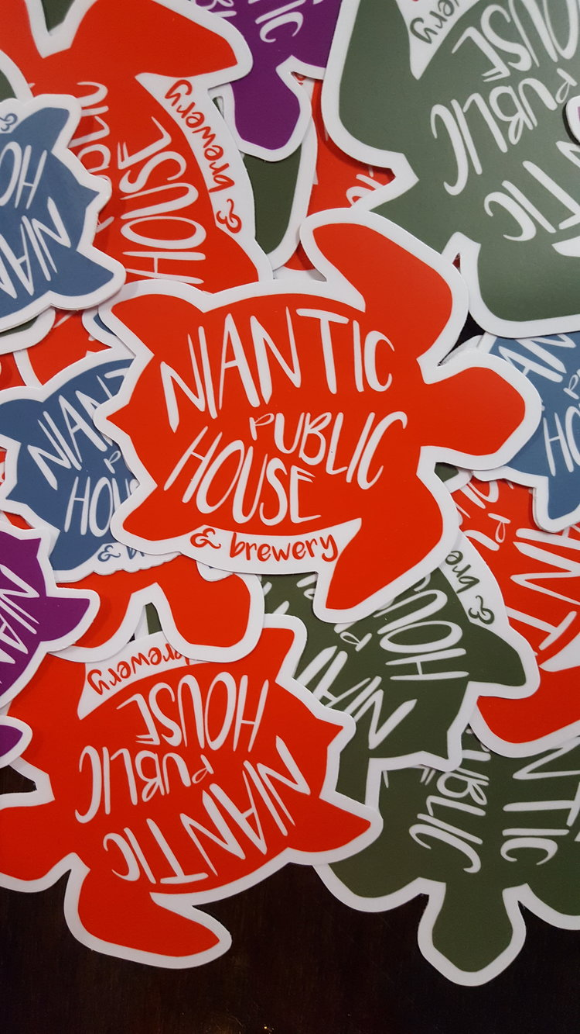

Location: Black Sheep, Niantic, CT; Followed by a stop at the Niantic Public House and Brewery

Date: Thursday, April, 25, 2019

Time: 4:00

Spring has sprung and we’re feeling a bit competitive, time for some PUB TRIVIA! That’s right, CEA Norwich Regional Office is bringing to you our very first pub trivia night. Get your best quiz teams together and get ready to take down your fellow educators. Let’s see who will reign supreme!