**Winter, 2019**

Gloria Dimon, UniServ Rep



***Upcoming Events:***

***MIDDLESEX COUNTY PRESIDENTS’FORUM***

***March 19, 2019***

***MIDDLESEX COUNTY FORUM***

***April 2, 2019***

***WATCH FOR OUR NEXT UBT BREWERY STOP!***

Teacher Strikes Continue to Build Across the Country

For many of you teaching is hardly recognizable from the profession you fell in love with. For many in America this has reached a boiling point and we have seen a wave of teacher strikes over the past 12 months from Arizona and Colorado to Oklahoma, West Virginia and California. The issues are not just compensation but huge systemic issues like lack of funding, classroom size, health benefits, and per pupil spending. While the issues may seem much more extreme than Connecticut (Avg. teacher salary for CT $73,174, CO $51,808, AZ $47,403, WV $45,555, OK $45,292), and teachers in L.A. fighting for class sizes smaller than 39 students, many of the other fundamental issues remain the same. Many of those teachers are without strong unions, or any union at all, and have been forced to take to the streets for any improvements. Now more than ever teachers are in need of support through their unions and each other to make education the wonderful profession you all know it can be! Will this be the year you become more active in your local? Don’t let things degrade to the point they have in other States. Support your union by becoming a building rep, attending an association meeting, serving on your bargaining team, or helping CEA make legislative change. There are numerous ways you can help bring about the change you want to see. We are at a tipping point where educators have had enough, let’s see this be the year you become involved!



***In this issue:***

***\* Teacher Strikes Continue to Build Across the Country***

***\* Know Your Rights – Parent Complaints***

***\* Spotlight On – Madison Education Association***

***\*Welcome Emmutt!***



#### Do you have questions about your individual situation with a parent complaint? Your UniServ Rep would be happy to help you.

#### Please call her at

#### 860-691-5031.





Q: What if the principal wants to meet with the teacher after the meeting to discuss what the teacher said during the meeting?

A: At that point, the teacher may have cause for concern. The teacher may bring a union representative if the purpose of the meeting is to interview the teacher about what was said, AND the teacher believes the meeting may result in discipline. If the teacher opts to meet alone with the principal, the teacher may interrupt the meeting and ask for representation at any time if the teacher believes the meeting may result in discipline.

Q: The parent puts a complaint about the teacher in writing. Will that letter go into the teacher’s personnel file?

A: It could go into the teacher’s personnel file. Each collective bargaining agreement has its own unique, negotiated language about what may go into a personnel file. Some contracts preclude anonymous complaints entirely. Some contracts require notice to a teacher prior to a document being place in a personnel file. Teachers are encouraged to review their own collective bargaining agreement for the rules about personnel files. In any event, if a teacher believes a document has been placed in the personnel file, the teacher has a legal right to make an appointment with administration to review the personnel file.

Q: The parent put a pack of lies in the letter that was sent to administration. Can’t the teacher require the district to destroy such a letter?

A: Unfortunately, once a document is sent to the administration, it becomes a public record under the Freedom of Information Act (FOIA), and the administration cannot destroy the letter. If a teacher feels strongly about the content of the letter, the teacher may prepare a rebuttal to the parent complaint and submit that to administration.

Q: The teacher is nervous about this meeting as the parent has been known to be combative in teacher meetings. So, is there anything the teacher the teacher can or should do?

A: The teacher should definitely speak to the principal prior to any such meeting. The teacher should explain to the principal the factual circumstances regarding the purpose of the meeting and the reasons why the teacher has concerns about the meeting. The teacher should attempt to get on the same page with the administrator regarding how the meeting will be conducted and what any anticipated outcomes may be.

Q: What if the parent sues the teacher as a result of what the teacher said at the meeting?

A: First of all, it is highly unlikely that would happen. Secondly, should a teacher be sued they are protected under the Save Harmless Law, CGS 10-235. In a nutshell, a teacher is protected by the Board of Education in actions for negligence and are held harmless unless a teacher’s actions are “wanton, reckless, or malicious.”

Q: A parent has a concern about an interaction a teacher had with their child, and the Principal wants to meet with the teacher and the parent together. They teacher would like the union representative to be present. May the teacher bring a building representative?

A: The short answer is “no.” Teachers are not entitled to union representatives in parent meetings. A meeting with a parent does not constitute an investigatory, pre-disciplinary meeting under Weingarten (a teacher’s right to have a union representative present). Secondly, it will likely only serve to increase the tension level and may give the parent the wrong impression about you.

Q: The teacher is nervous about this meeting as the parent has been known to be combative in teacher meetings. So, is there anything the teacher the teacher can or should do?

A: The teacher should definitely speak to the principal prior to any such meeting. The teacher should explain to the principal the factual circumstances regarding the purpose of the meeting and the reasons why the teacher has concerns about the meeting. The teacher should attempt to get on the same page with the administrator regarding how the meeting will be conducted and what any anticipated outcomes may be.

Page 2 of 3

This Month’s Topic: Parent Complaints

**Know Your Rights**, with Gloria Dimon,   
CEA UniServ Rep

#### LOCAL SPOTLIGHT ON:

MADISON EDUCATION ASSOCIATION MEMBER DANIELLE FRAGOSO

Page 3 of 3

Everyone please welcome the newest addition to CEA K9 Division, Emmutt Teifke!

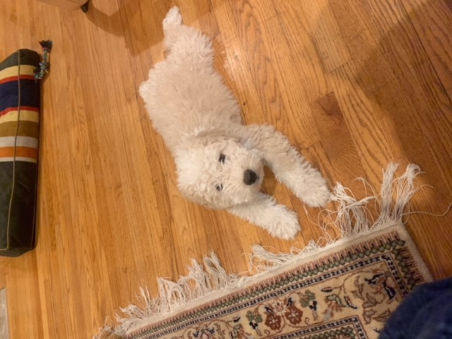

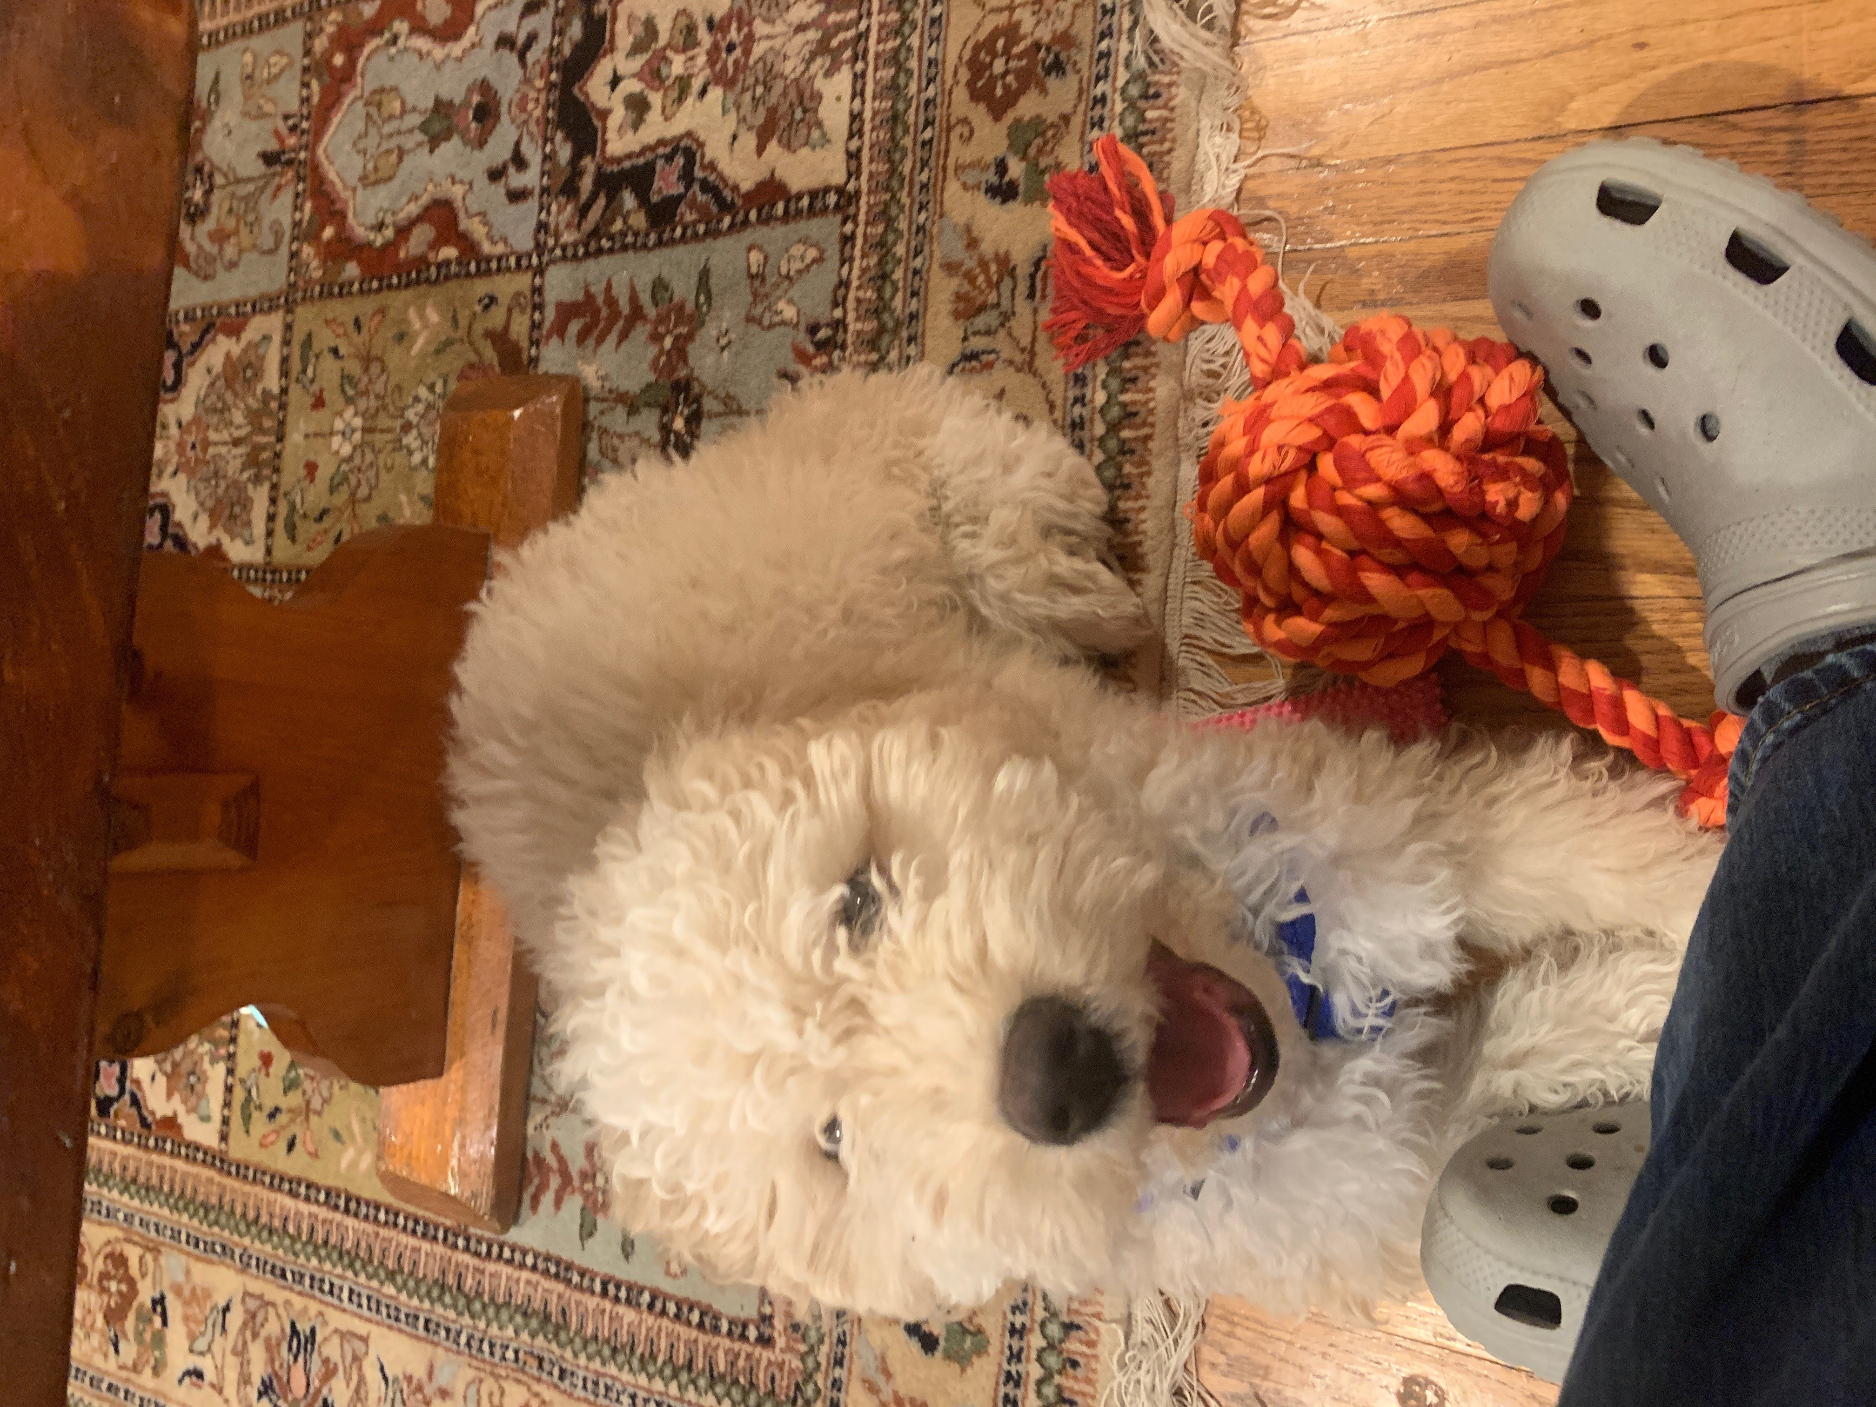

Emmutt is a 12 week old Spanish Water Dog whose interests include Social Justice, Public Education and chewing on sneakers. He is very excited to join the team and help all teachers with a smile after a rough day. Welcome Emmutt!

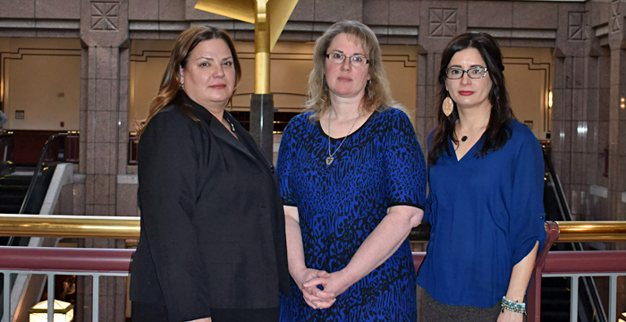

**Danielle (left) Provides Testimony To Education Committee**

Unlike many teachers throughout the state, Madison high school special education teacher Danielle Fragoso says she is supported by her administration and encouraged to speak out to protect her students and her colleagues.

"During my 15 years in Connecticut classrooms, I have been stabbed in the back with a pencil, requiring medical attention. I have had to run across four lanes of traffic chasing students who fled the building. I have had to pull a student off another child who was being choked. In our classroom kitchen, an agitated student kicked a paraprofessional in the stomach, thrusting her three feet back onto the floor. My fellow teacher and I tried to restrain him, but he pulled away, punched me in the eye, and eventually lunged for a large knife. I held his hand as he tried to stab us. He was shouting that he wanted us dead and asking why it was so hard to take down two women. After 15 minutes, we finally got the knife away, and he ran. Luckily there were two of us, or the outcome would have been much different. My only thoughts were of my students and hoping none of them would get hurt."

Please contact your legislator to support House Bill 7110, An Act Concerning Enhanced Classroom Safety and School Climate, which would require schools to help students exhibiting extreme behaviors, provide increased student supports and teacher training, and address children's mental health and social-emotional needs.